Building trees using PAUP*

Rod Page (r.page@bio.gla.ac.uk)

These short exercises are designed to give you quick introduction to phylogenetic analysis using MacClade and PAUP*. Work through these exercises. They introduce building trees using different methods, how to view those trees, and get some idea of their robustness. If you run in to problems ask the demonstrator.

Where are the data files?

All the data files are in the folder “Bioinformatics” user folder on your Mac.

All the data files are in the folder RDMP\Data within the P:\MRESDATA folder on the MRes PC’s.

PAUP*

Starting PAUP*

PAUP* is started by clicking on program icon:


Go to the file menu and open a data file. Once the data is read you can enter commands in the command line (Mac, Windows and Unix), or using the menus (Mac).

Simply type in the command and press Enter.

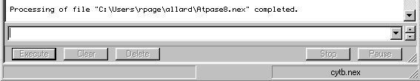
All your results appear in the Display window.

How do I get help?

To get a quick summary of commands type help. To get detailed help for a particular command type the name of the command followed by ?

How do I get a tree?

One quick way is to do a heuristic search. Type the command:

hs

or go to the Analysis menu and choose Heuristic Search. Accept the default settings and click on the Search button.

How do I get a neighbour-joining tree?

Type the command:

nj

or choose Neighbor Joining/UPGMA from the Analysis menu.

How do I change the optimality criterion?

Use the set criterion command. For example,

set criterion = parsimony

set criterion = likelihood

or choose the corresponding option from the Analysis menu:

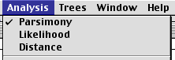

How do I show my trees?

The best tree (or trees) can be shown in the Display window issuing the command

showtrees

How do I print my trees?

On a Mac you can go to the Trees menu and choose Print tree or Print NJ Tree… (if you computed a neighbor joining tree. You will see a dialog box like this:

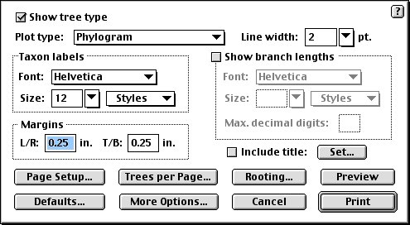

PAUP can print the tree in a variety of styles. For now, just choose the Plot type Phylogram and click Preview. You will see something like this:

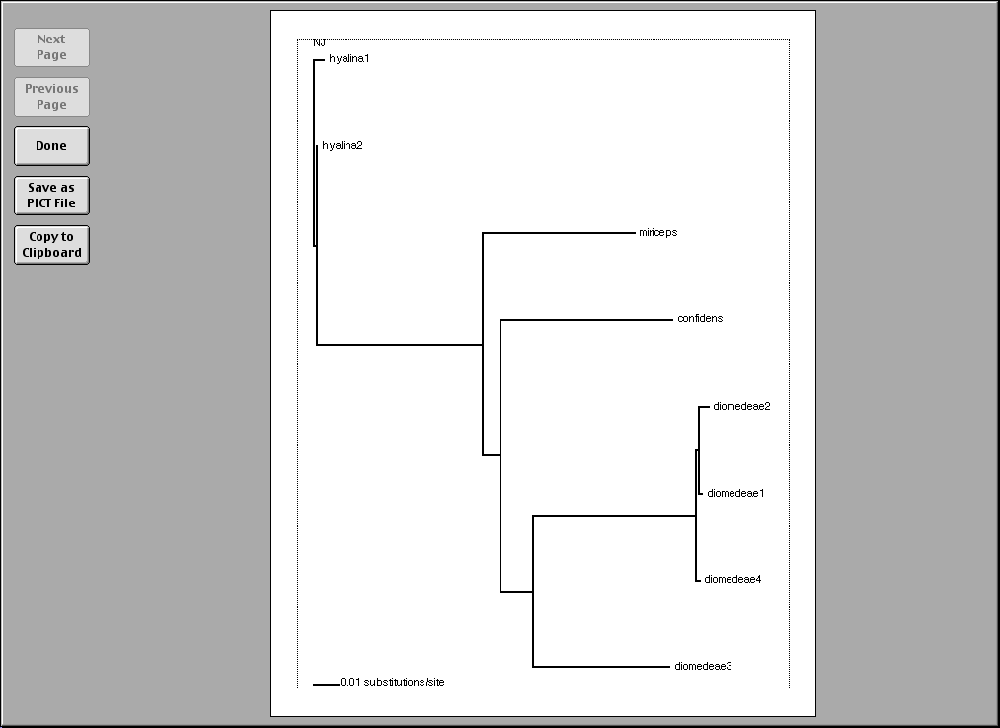

If you like what you see, click on the Done button. You will be taken back to the Print NJ tree dialog box shown above. Click Print and your tree will be printed.


If you’re not using a Macintosh then you need to save the trees and print them using a tree viewing program such as TreeView or treeView X. To do this

- Enter the command savetrees (or savetrees brlens=yes if you want branch lengths)


- PAUP* saves the tree file, which on a PC will have the following icon:
- Open this file in TreeView (e.g., by double clicking on it). You can print the tree (or trees).

Part 1: Building trees

To do:

Open the data file “Hominoid mtDNA.nex” in PAUP*. Build a parsimony tree using a heuristic search. View it in the display window (showtrees). If you wish, save it to a file (savetrees) then view that file in TreeView.(or print it from within PAUP).

For small numbers of sequence you can compute the parsimony score for all possible trees. Use the command alltrees to do this.

Q: What does the plot of tree lengths tell you? How confident are you that the shortest tree is the true tree?

To do:

Change the optimality criterion to likelihood (set criterion = likelihood). Find the maximum likelihood tree (hs).

Q: Is it the same as the parsimony tree?

To do:

Compute likelihood scores for all possible trees (alltrees).

Q: How does this compare to the results for parsimony?

Comparing likelihood and parsimony scores

The plot below was constructed by outputting likelihood and parsimony scores for the same tree (using the command alltrees scorefile=<filename>).

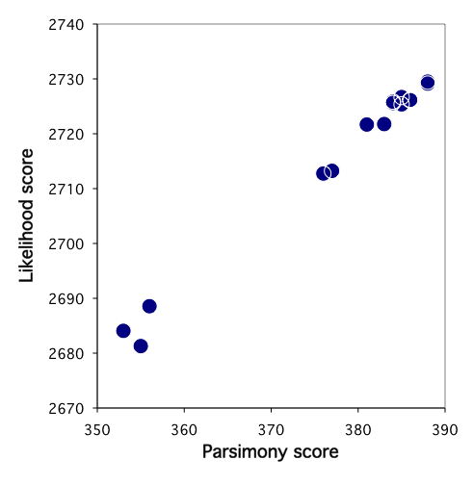

Q: What does this plot tell you about the two methods?

To do:

As a final exercise in this section, compute a neighbour-joining tree (nj).

Q: How does it compare to the parsimony and likelihood trees?

Part 2: Trees with confidence

The bootstrap is a commonly used way of assessing how robust a tree is.

To do:

Set the optimality criterion to parsimony and run a bootstrap analysis (bootstrap).

Q: What do the numbers on the branches mean?

Q: What can you say about the three alternative hypotheses concerning relationships among the African apes?

To do:

Change the optimality criterion to likelihood, and redo the bootstrap.

Q: How do the results compare to parsimony?

Part 3: Congruence among mitochondrial genes

In this exercise you will each analyse a different mitochondrial protein-encoding gene for the same set of mammal species. Each gene is in a separate file in the folder “Allard & Carpenter”.

To do:

Analyse your file as you see fit. Once you’ve come up with a tree you’re happy with, compare it with those found by your classmates.

Q: Are the trees the same or different, if so, why? Be prepared to discuss these results at the next class meeting.

